**Data**

The data acquired from Wikipedia pages and restructure to csv file for easier manipulation and reading. Both files uploaded to my GitHub for references. Link to the files are:

* [Mumbai_district.csv](https://github.com/skakkara-in-ibm-com/Coursera_Capstone_Assignment1/blob/master/Mumbai_district.csv)
* [Pune_district.csv](https://github.com/skakkara-in-ibm-com/Coursera_Capstone_Assignment1/blob/master/Pune_district.csv)

Another aspect to consider for this project is the Foursquare data. I believe that the data as good as provided, meaning although we are using Foursquare data for segmentation and clustering, the amount and accuracy of data captured can't 100% determine correct classification in real world.

To start, let's get and look at the data. I've already downloaded it, so let's read it (from local drive) and load it to dataframe: Using geocoder, we able to get Latitude and longitude for each area.

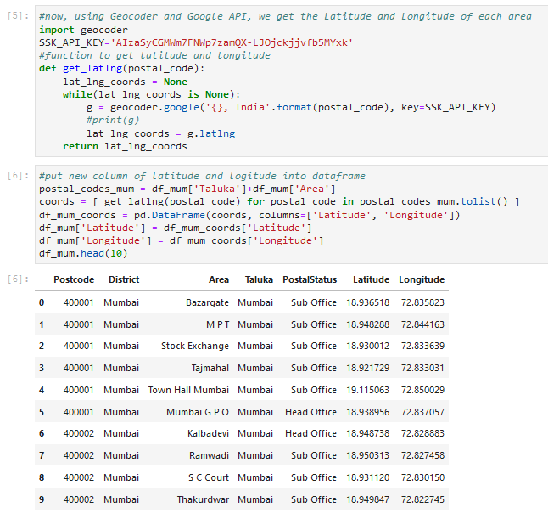

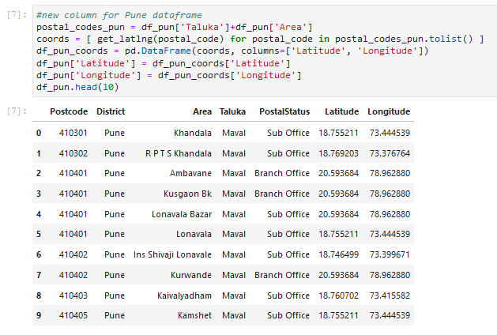

**Methodology**

In this project, I will use the basic methodology as taught in Week 3 lab.

* Above, we have done convert addresses into their equivalent latitude and longitude values.
* Then we will use the Foursquare API to explore neighbourhoods in both cities, Mumbai and Pune
* After that, explore function to get the most common venue categories in each neighbourhood,
* and then use this feature to group the neighbourhoods into clusters

K-means clustering algorithm will be using to complete this task. And the Folium library to visualize the neighbourhoods in Mumbai and Pune and their emerging clusters.

Based on dataframe analysis above, we found out that **Mumbai Taluka** in **Mumbai** and **Pune City Taluka** in **Pune** are both have the highest number of area within it those districts.

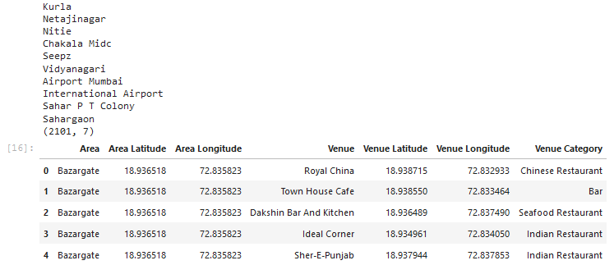

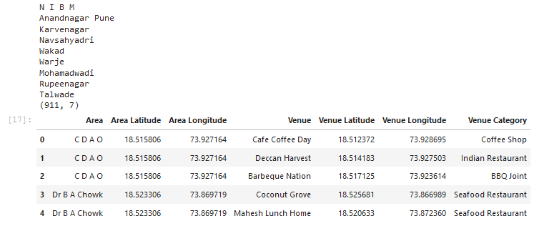

**Analyse Mumbai**

Analysing Mumbai data to get most common venue for each area.

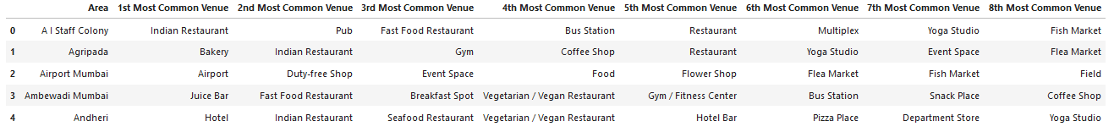

**K-mean Cluster Mumbai**

Using K-mean to clustering data area with most common venue

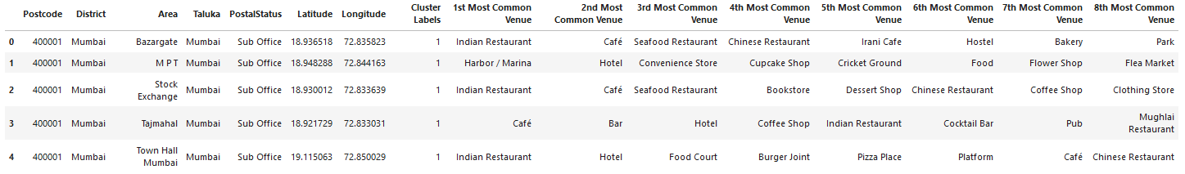

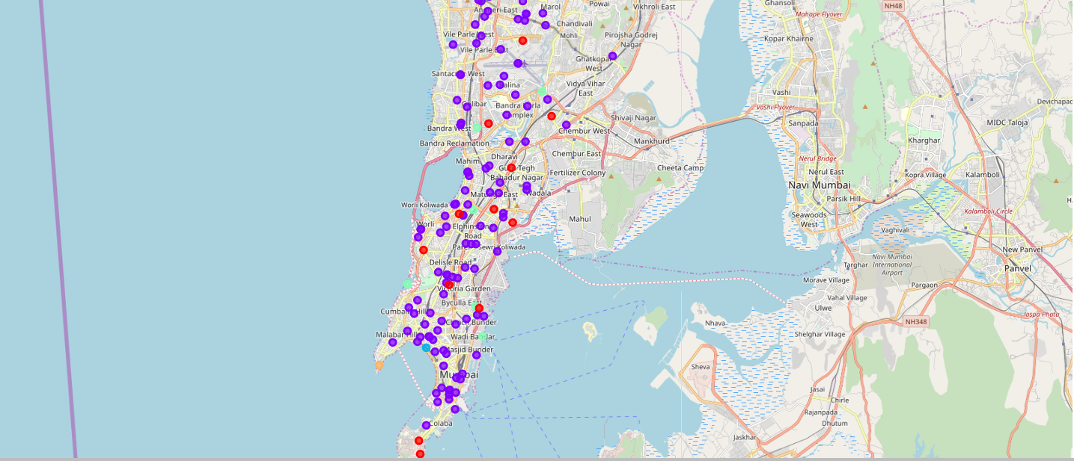

**Analyse Pune**

Analysing Pune data to get most common venue for each area.

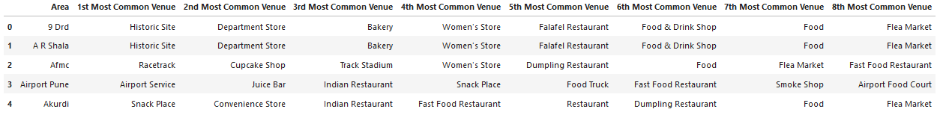

**K-mean Cluster Pune**

Using K-mean to clustering data area with most common venue

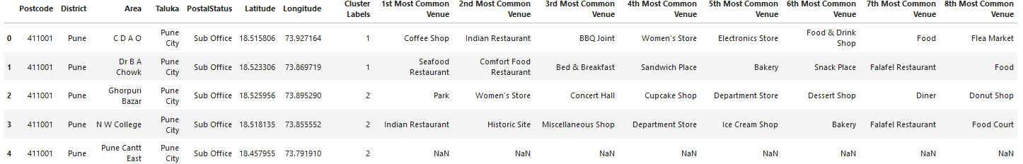

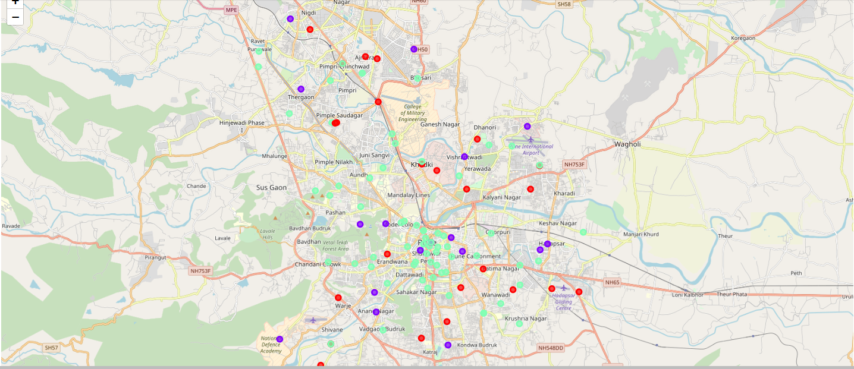

**Result**

Cluster 1 for Mumbai

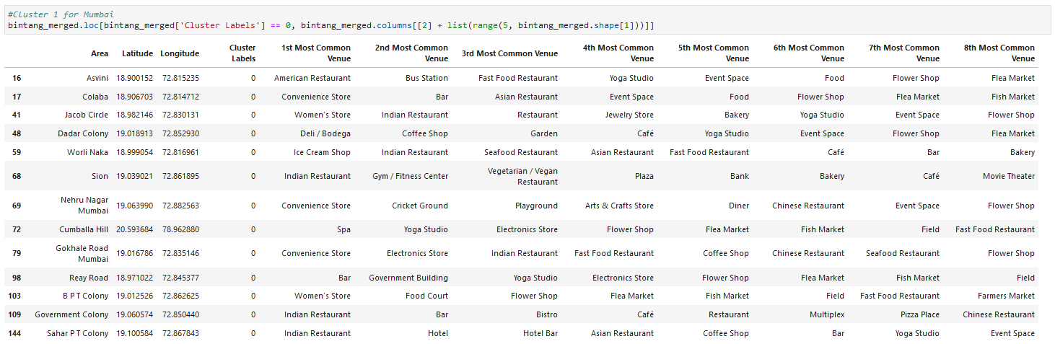

Cluster 2 for Mumbai

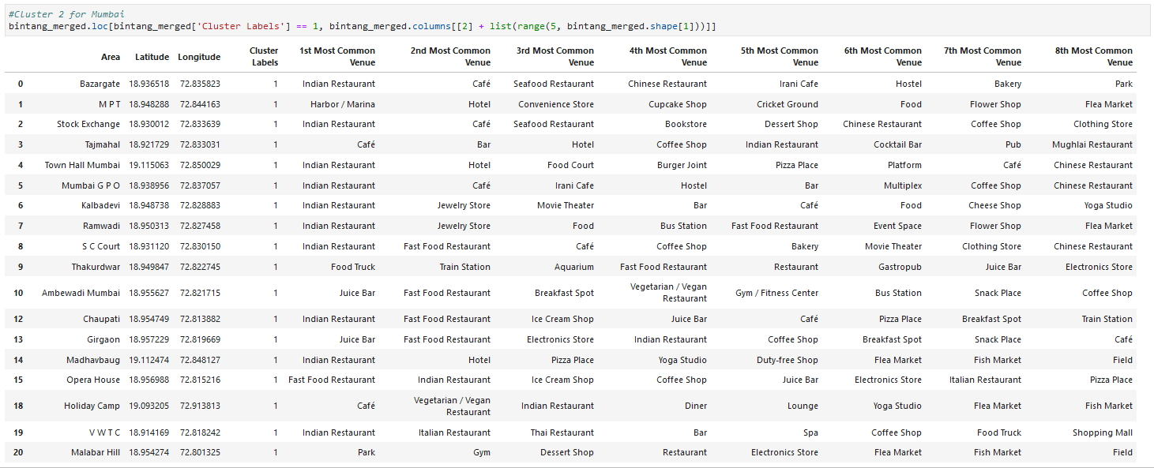

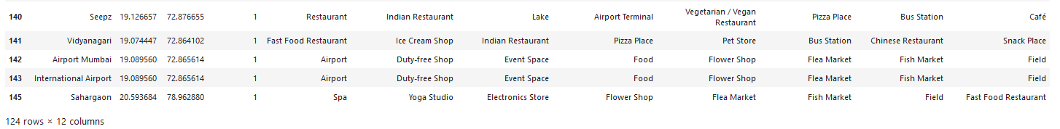

Cluster 3 for Mumbai



Cluster 1 for Pune

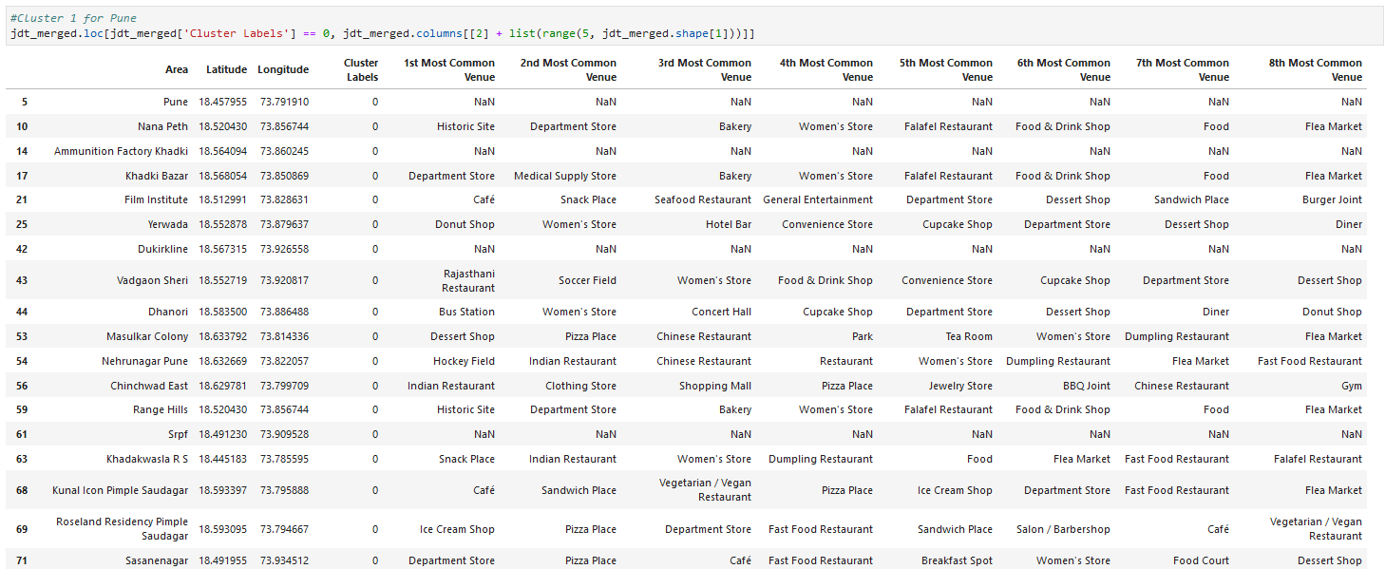

Cluster 2 for Pune

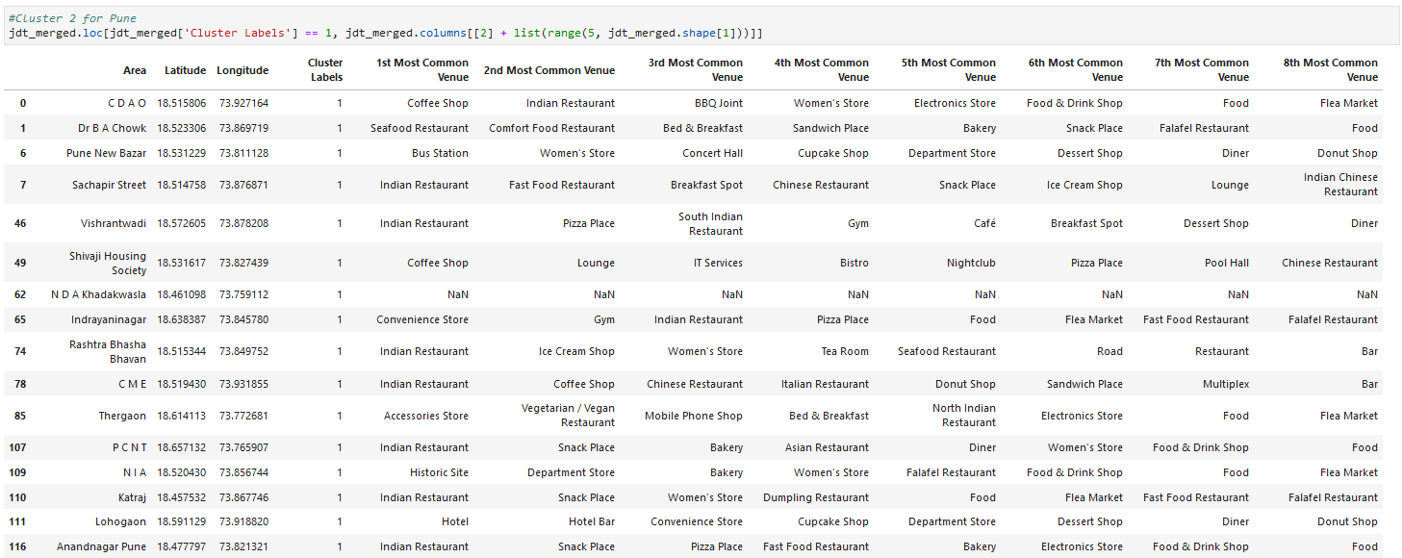

Cluster 3 for Pune

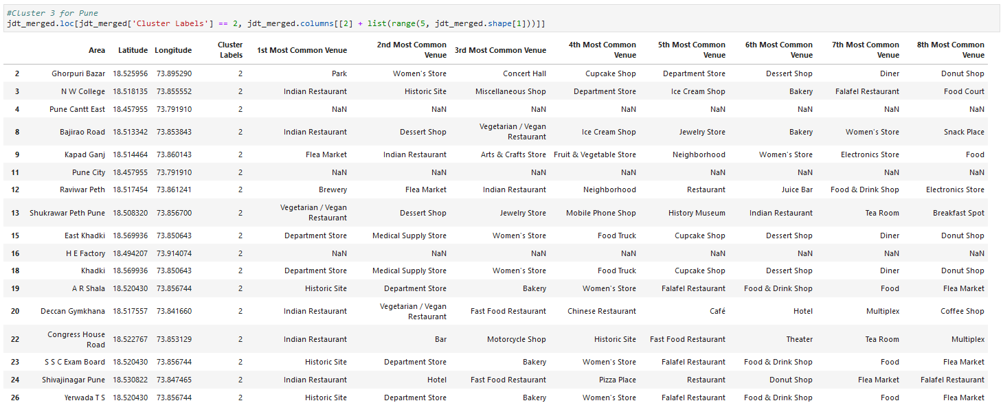

**Discussion**

Based on cluster for each city above, we believe that classification for each cluster can be done better with calculation of venues categories (most common) in each cities. Referring to each cluster, we can't determine clearly what represent in each cluster by using Foursquare - Most Common Venue data.

However, for the sake of this project we assumed each cluster as follow:

Cluster 1: Mumbai: Shopping

Cluster 2: Mumbai: Mix

Cluster 3: Mumbai: Food

Cluster 1: Pune: Tourism

Cluster 2: Pune: Residential

Cluster 3: Pune: Mix

What is lacking at this point is a systematic, quantitative way to identify and distinguish different district and to describe the correlation most common venues as recorded in Foursquare. The reality is however more complex: similar cities might have or might not have similar common venues. A further step in this classification would be to find a method to extract these common venues and integrate the spatial correlations between different of areas or district.

We believe that the classification we propose is an encouraging step towards a quantitative and systematic comparison of the different cities. Further studies are indeed needed in order to relate the data acquired, then observe it to more meaningful and objective results.

**Conclusion**

Using Foursquare API, we can captured data of common places all around the world. Using it, we refer back to our main objectives, which is to determine;

the similarity or dissimilarity of both cities classification of area located inside the city whether it is residential, tourism places, or others In conclusion, both cities Mumbai and Pune are the center of attraction among Indian. However, to declare both cities are similar or dissimilar base on common venues visited is quite difficult. Both cities is similar in some venues also dissimilar in certain venues. And for classification based on common venues, again we must have more systematic or quantitative way to identify and declare this. Comparison can be made, but no such method or quantitative data to determine this. We hope in the future, a method to determine it can be establish and explore for references.